1. Difference equation

y(n) = b0 x(n) + G * y(n-N)

b0 = 1.0

G = 0.8

RATE = 16000

delay_sec = 0.05

N = int (RATE * delay_sec )

N = 800

y(n) = (1.0)* x(n) + (0.8) * y(n-800)

2. Transfer Function

Y(Z)

H(Z) = 1/(1 – (0.8) ×)

3. Impulse Response

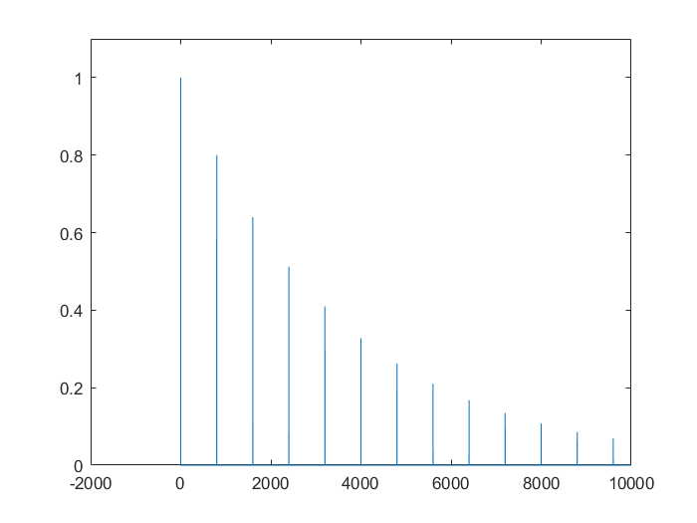

4. Pole-Zero Plot

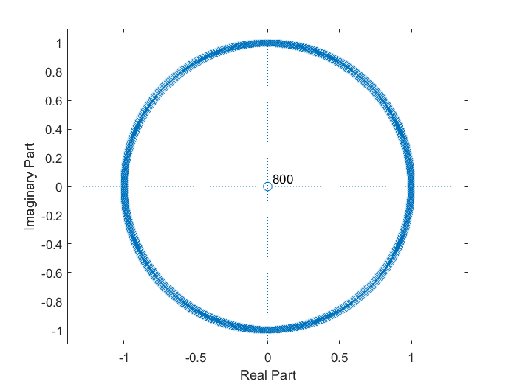

5.

Changing buffer[k] = x0 to buffer[k] = y0, multiple echoes of input sound can be heard in output.

6.

Changing the gain of the delayed signal to greater than 1, volume(magnitude) of echo goes on increasing and completely overshadows the original input signal.